State Brochure

You will create a travel brochure filled with strange and wonderful facts about your state. You may use my template, or create your own by hand or on the computer. You should include the following items below and information about them, as well as odd facts and tidbits that makes the state interesting:

Cover – Eye catching, outside right  - State name  - Picture of the state  - Your name  Geography – Paragraph, inside left  - Region the state is in  - Surrounding states  - Major landforms (rivers, mountains, lakes, etc.)  - Climate (what is the weather like  - Picture  State information – Facts, inside center  - State capital  - Population  - State nickname  - State flower  - State bird  - Any other “state” facts (food, rock, animal, song, etc.)  - Picture  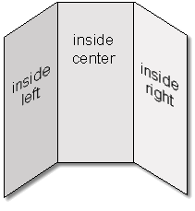 | Economy – Paragraph, inside right  - Natural resources  - Popular industries  - Picture  Tourism – Paragraph, outside left  - Major cities (at least 3)  - Vacation spots or other fun things to do  - Major landmarks  - Sports teams (college and professional)  - Picture  Fun Facts – Written in fact form, outside center  - 3-5 interesting facts about your state

